Contents
Is service project ASP.NET Core project? Do you guys use dotnet CLI commands to publish it? 2
dotnet publish WarrantNow.Core.csproj --configuration Release --self-contained false -r win-x64 2
dotnet publish WarrantNow.Core.csproj --configuration Release --self-contained false -r linux-x64 don’t appear to work. Is it cross-platform or windows only? 3
How do you publish/release it? Project build and then manual file copying? 3

Is service project ASP.NET Core project? Do you guys use dotnet CLI commands to publish it?
Thinkerz Comments
No , Service Project is not ASP.NET Core project. Its .NetFrameWork 4.5 Project (below Project Properties.)
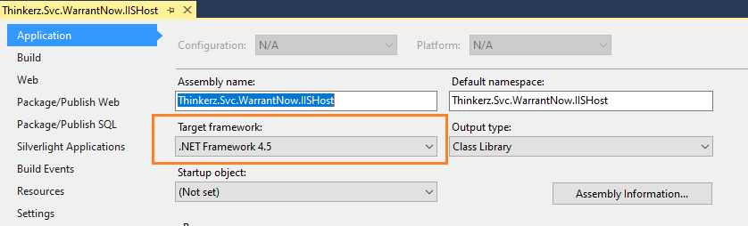

dotnet publish WarrantNow.Core.csproj --configuration Release --self-contained false -r win-x64
Thinkerz Comments
WarrantNow.Core.csproj project is not part of WarranNow 2.0 service project. It’s Part of Web UI application.

Below is the details for WarrantNow web application.
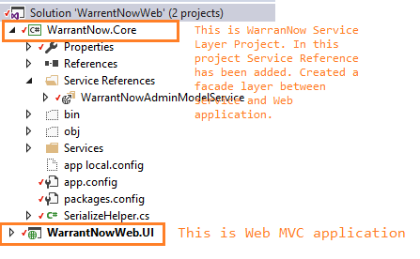

Below is the details for WarrantNow Service application.
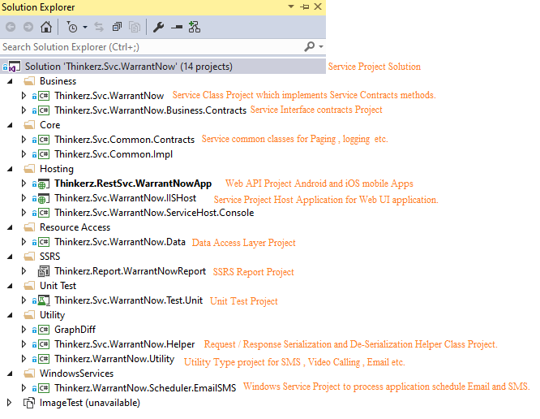

dotnet publish WarrantNow.Core.csproj --configuration Release --self-contained false -r linux-x64 don’t appear to work. Is it cross-platform or windows only?
Thinkerz Comments
WarrantNow.Core.csproj is Class Library project and work as Façade layer between Service and Web UI application. So we don’t need to release this project. If we release WarrantNowWeb.UI project this WarrantNow.Core.csproj project build and update dll as dependent project.
WarrantNow Service or Web UI project developed based on .NetFramework 4.5 , so its work on Windows Only , it does not work cross-platform.

How do you publish/release it? Project build and then manual file copying?
Thinkerz Comments
Below process we follow to publish/release WarrantNow 2.0 Service and Web UI project.
Below steps we follow to publish Process for WarrantNow2.0 Service.
Step1 : Set all project in the solution as “Release” as per below screenshot. (one time configuration unless anyone updates this configuration persists.)
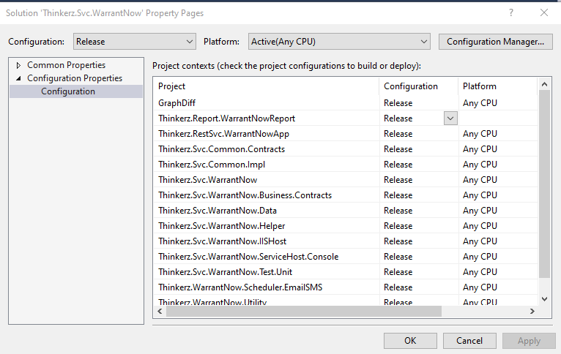
Step 2: Right Click on Thinkerz.Svc.WarrantNow.IISHost project and click on Publish link.
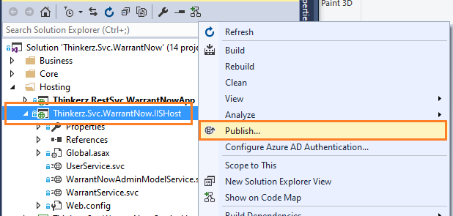

Step 3: Select “File System” as Publish Method and choose target location and click Next.
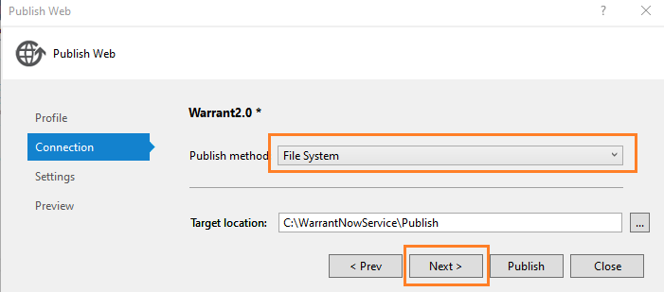

Step 4: In configuration select “Release” and Click “Next”.
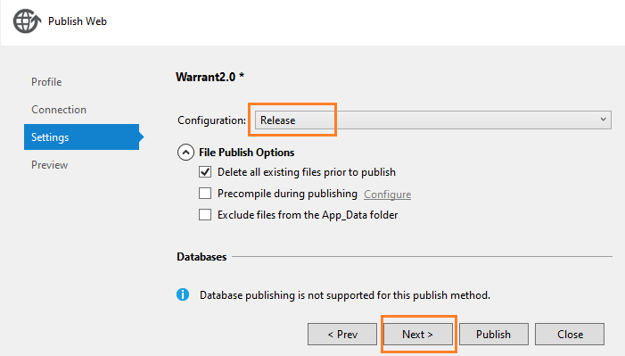

Step 5: Click on “Publish”.
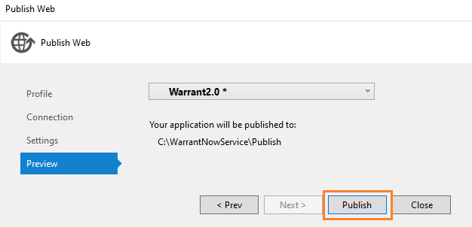

Step 6: Check publish status on OutPut Window.
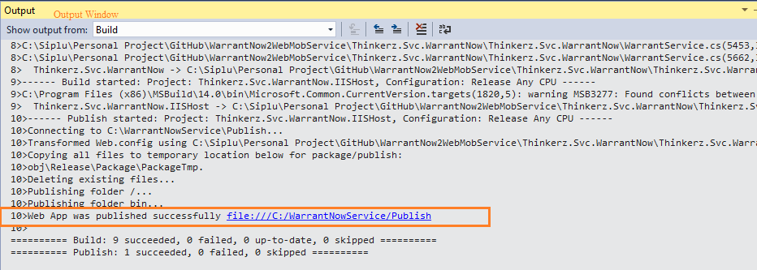

Step 7: Once publish successful, release files created. Copy the file and paste into IIS WebSite physical folder.
During publish we need to take care below points:
- Please don’t copy Web.config file from Dev to UAT , Prod or Vice Versa. As it might override existing configuration setting.
- If there is any new configuration please add or update manually in Web.Config file.
